**Creating Alerts with DNIF**

Dnif provides feature to create alerts which enable users to trigger reports if the specified conditions in the query are met.

In order to create reports, follow the steps mentioned below:

Under “Management” Tab, click on Repository option

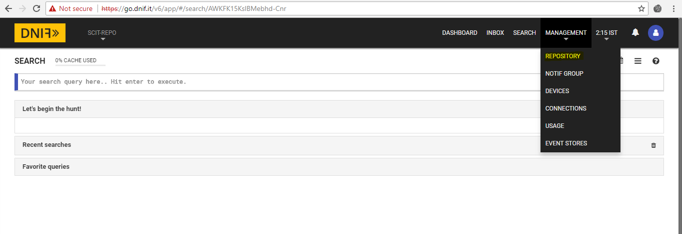

Create a new repository in order to create and visualize reports within the created repository.

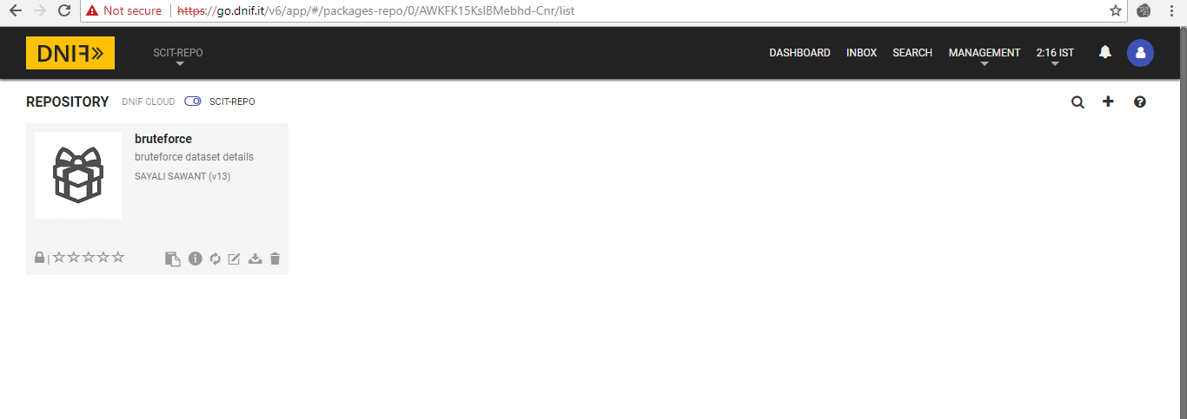

In order to add a new Report , Click on “+” icon within the repository , and click on “Report” option from the given menu.

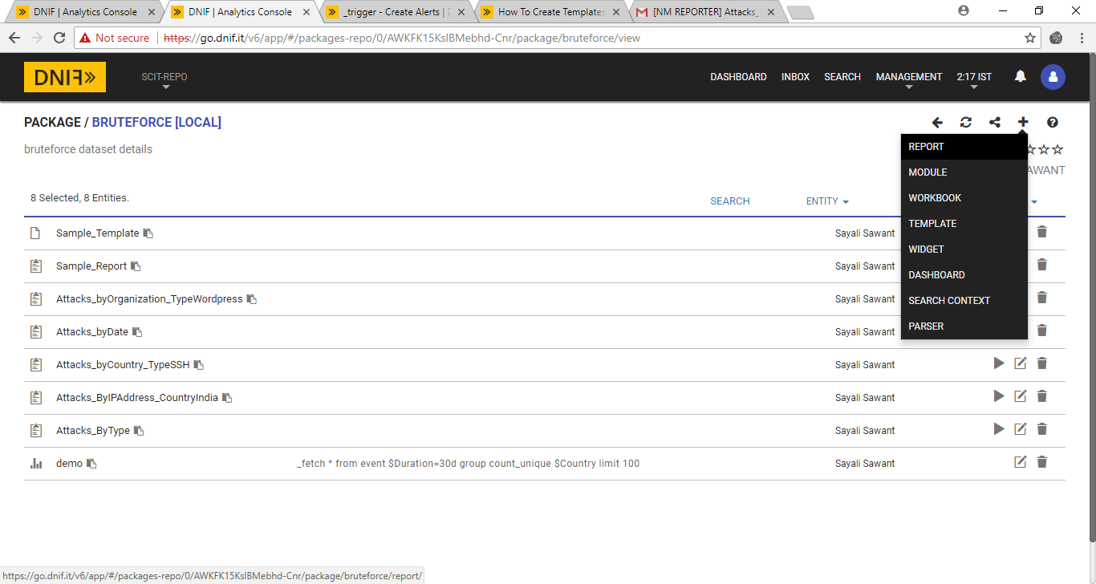

Enter the mandatory fields :

Name of the Report

Add Data Table using DQL queries as shown below in order to retrieve the required results in the Report. Here report is generated to count the unique number of attacks occurred based on Country field within the last one month.

Query : _fetch * from event where $Duration=30d limit 100

count_unique $Country

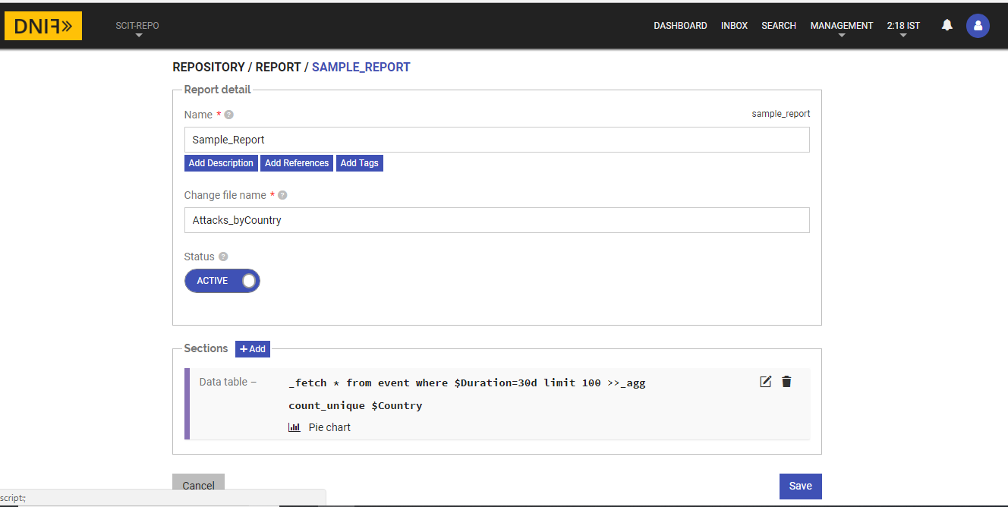

Click on “Save” button, created Report will be visible as shown below under the repository

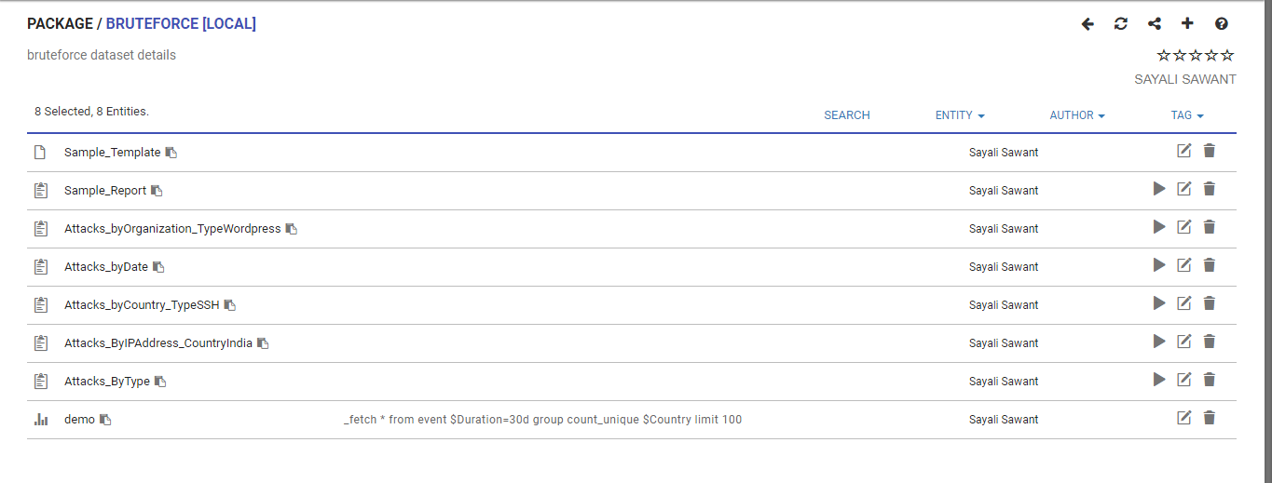

In order to trigger email alerts for the created report use the following query:

_trigger report bruteforce sample_report notify_email [sayalisawant1518@gmail.com](mailto:sayalisawant1518@gmail.com)

Where,

* **bruteforce** is a slug name of the package which contains the required report template.
* **Sample_report** is a slug name of report template.
* **notify_email** is a parameter to send an email.
* **sayalisawant1518@gmail.com.com** is the target email address to whom the report needs to be sent.

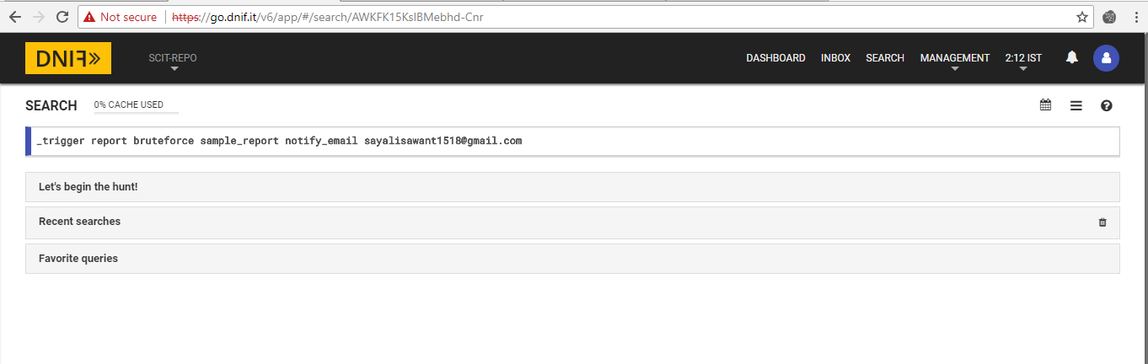

Similarly , alerts can be generated as demonstrated below for different conditions using queries and notify the user via email for the same.

1.

Email Trigger: Generating email as shown below to record the list of attacks occurred country-wise in the past one month.

_fetch * from event where $Duration=30d limit 100

count_unique $Country

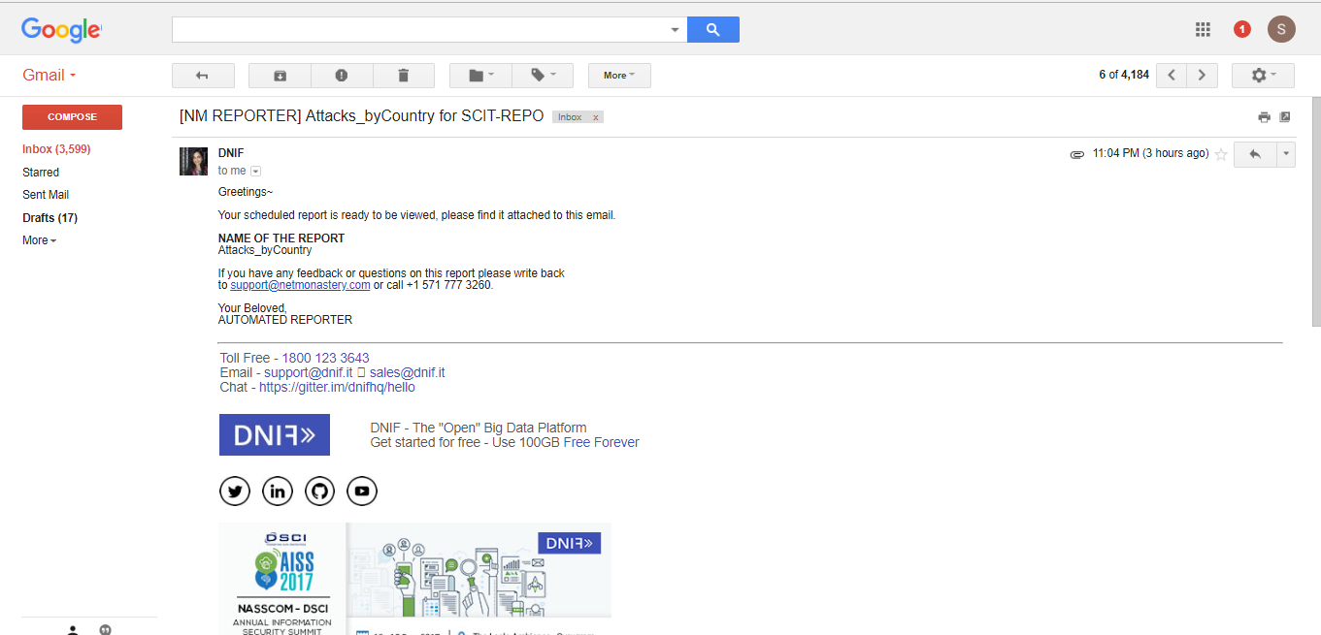

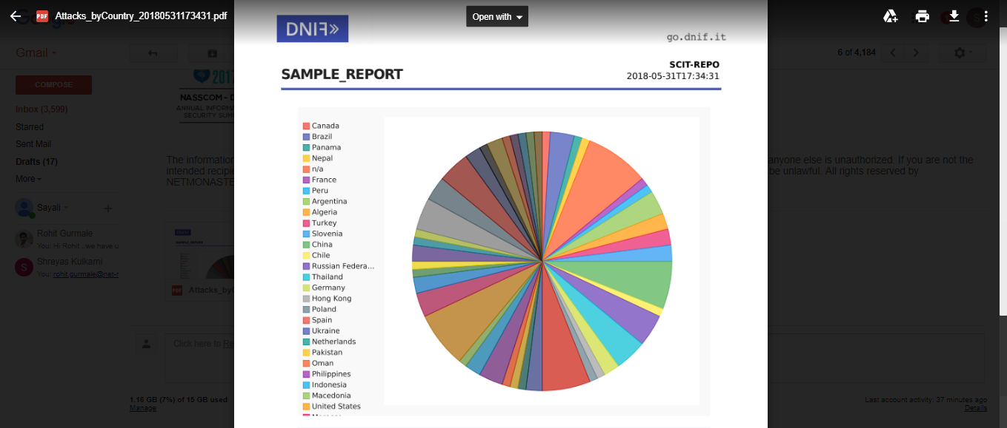

2. To trigger an email based on the organization based on the type of attack being Wordpress.

Query : _trigger report bruteforce attacks_byorganization_typewordpress notify_email sayalisawant1518@gmail.com

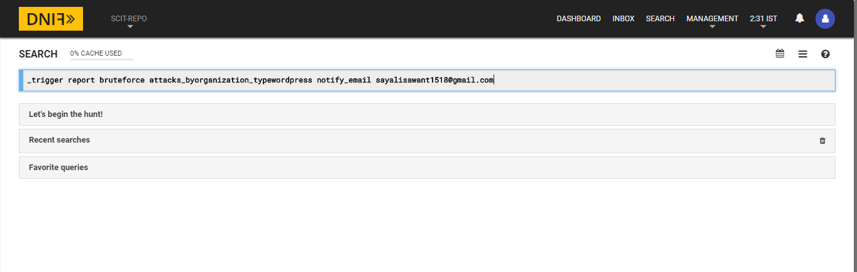

Report:

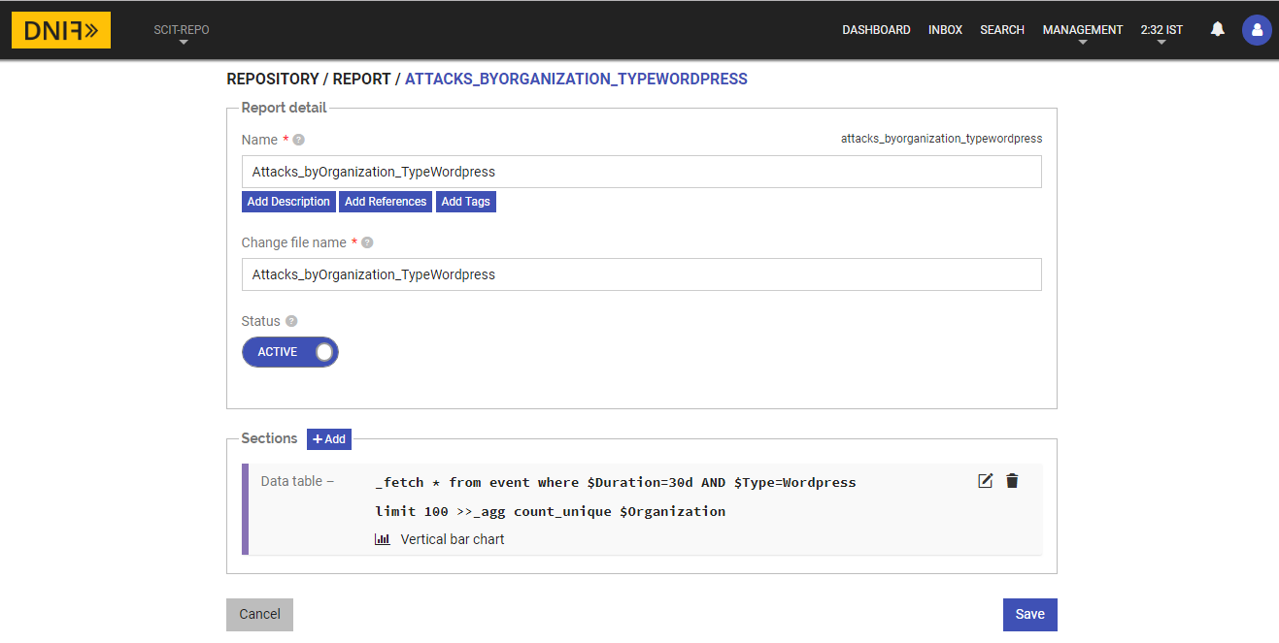

Email:

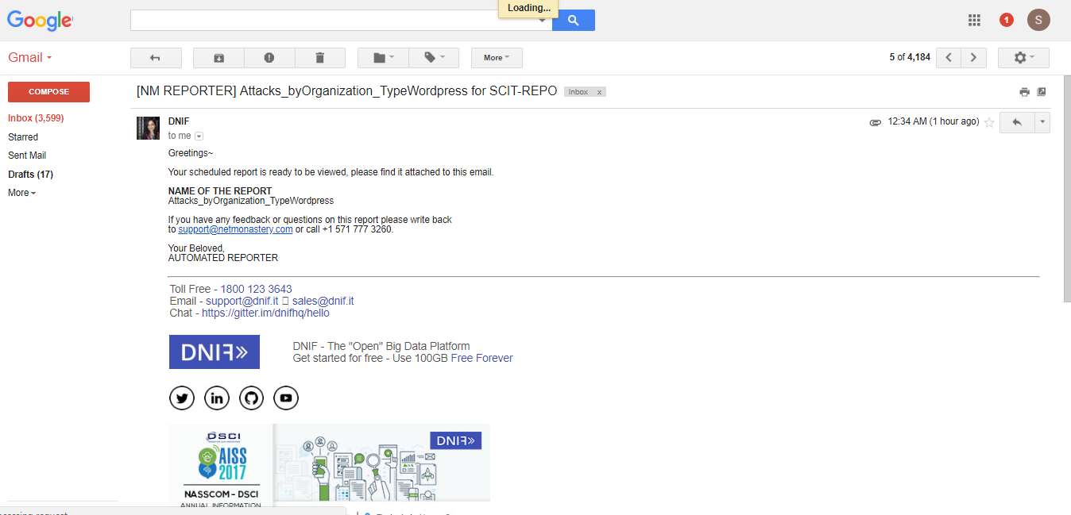

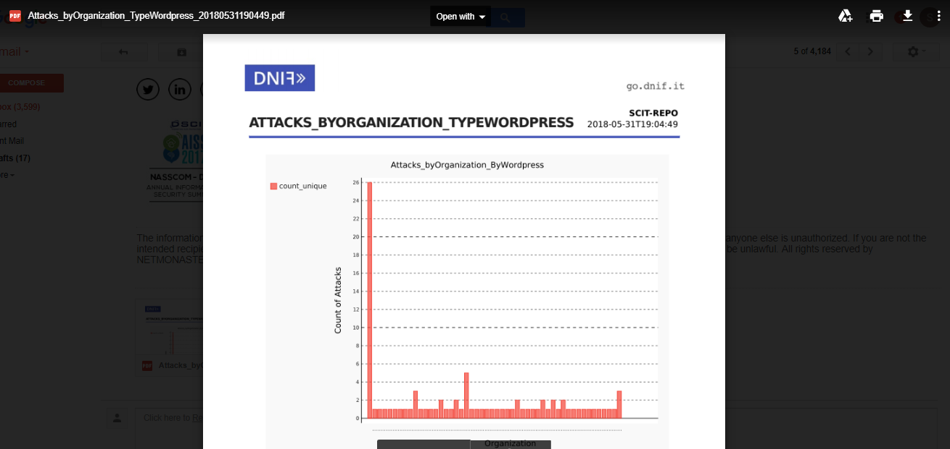

3. To trigger an alert based on the date of the originating attack.

_trigger report bruteforce attacks_bydate notify_email sayalisawant1518@gmail.com

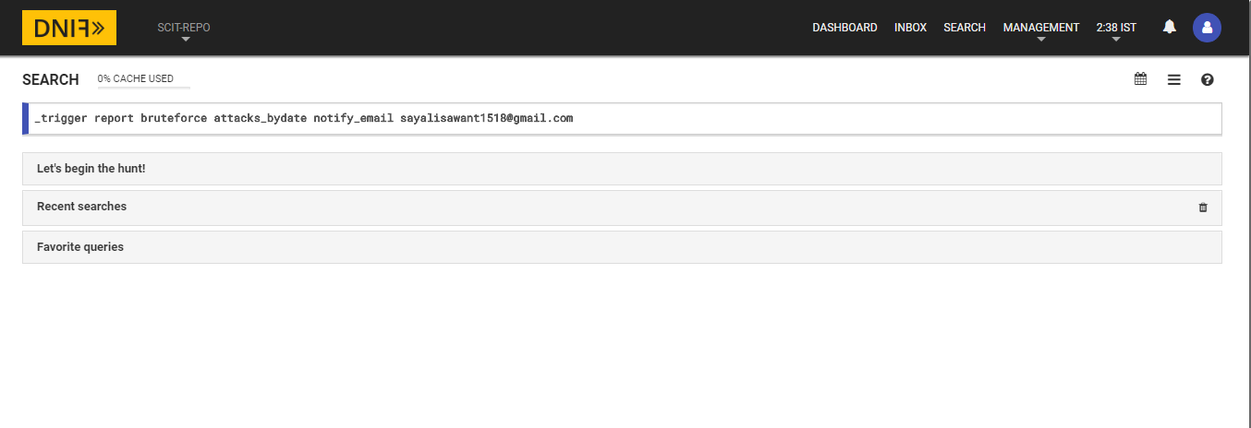

Report

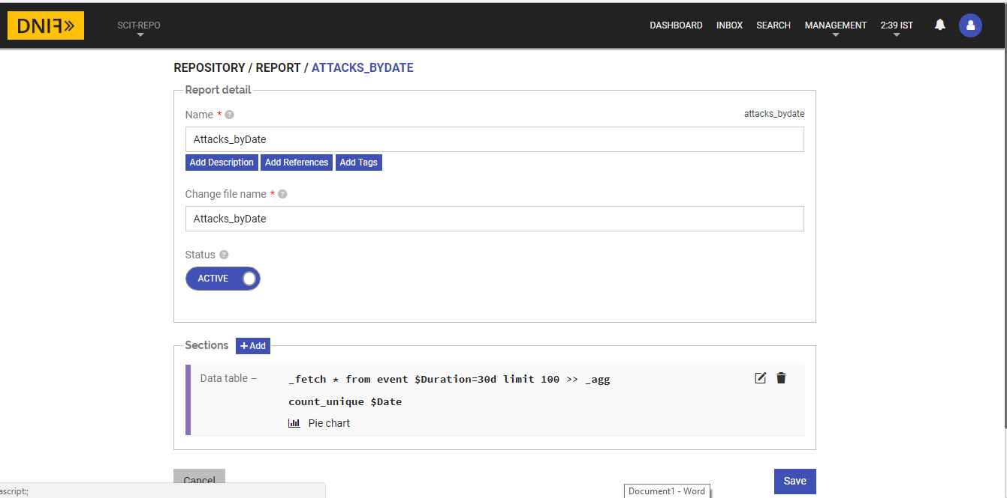

Email:

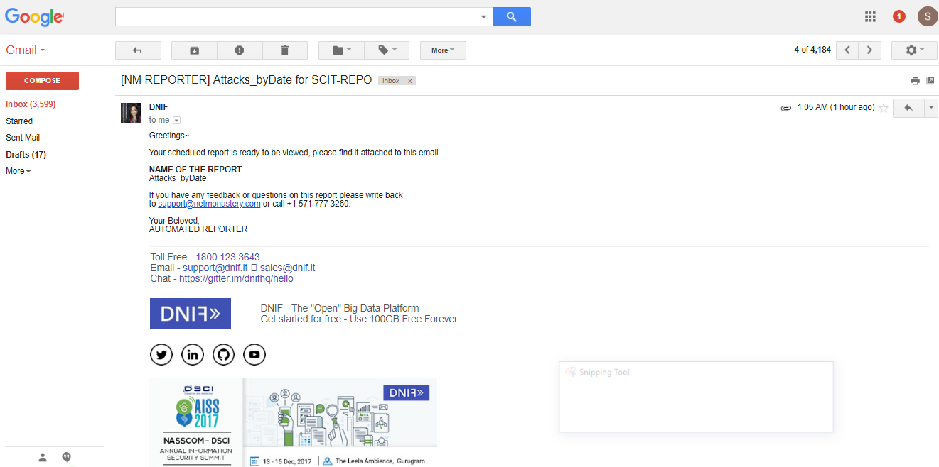

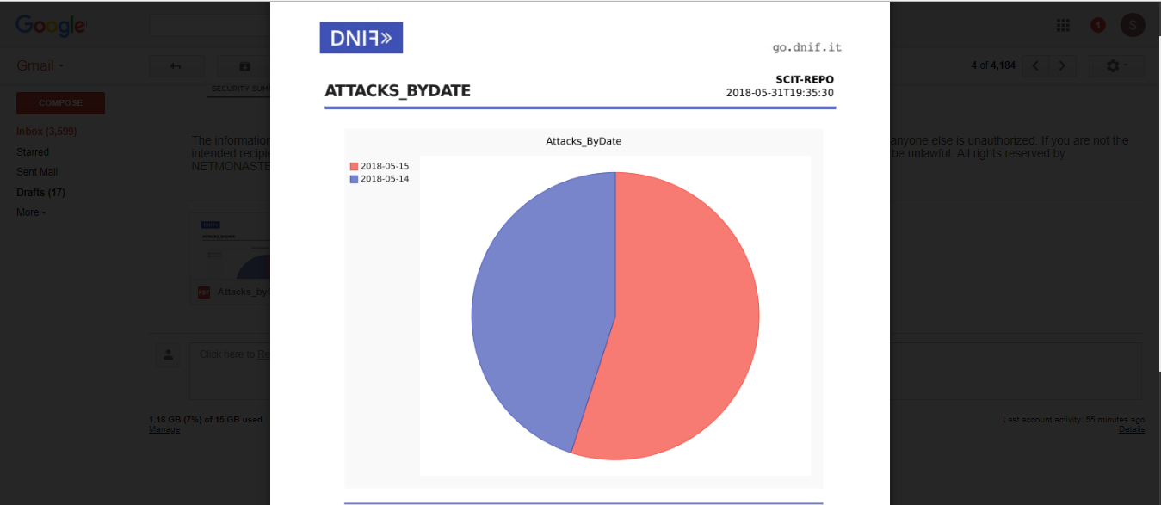

4. Query: To trigger an alert for the user based on Type of the attack originating countrywise.

_trigger report bruteforce attacks_bycountry_typessh notify_email sayalisawant1518@gmail.com

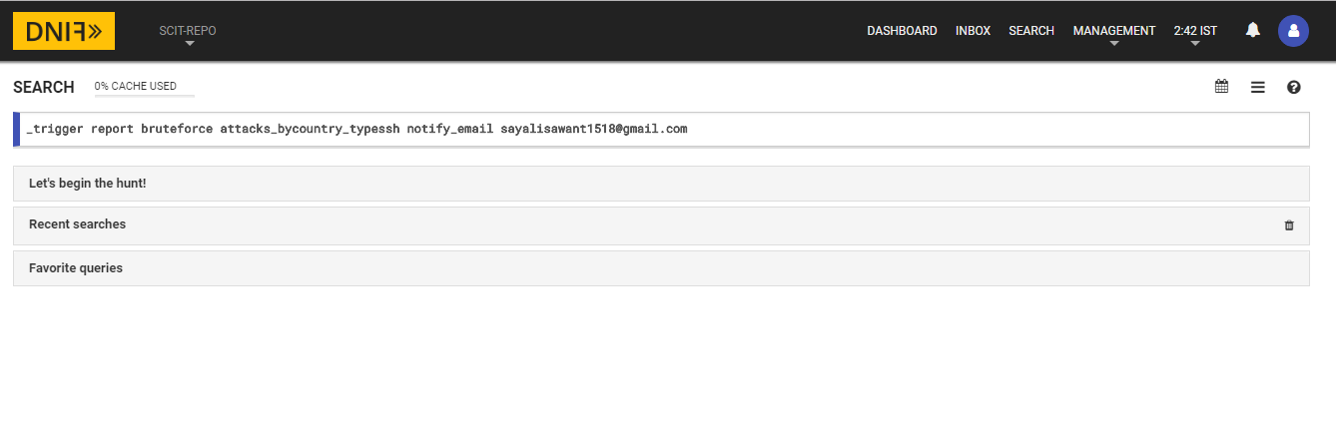

Report:

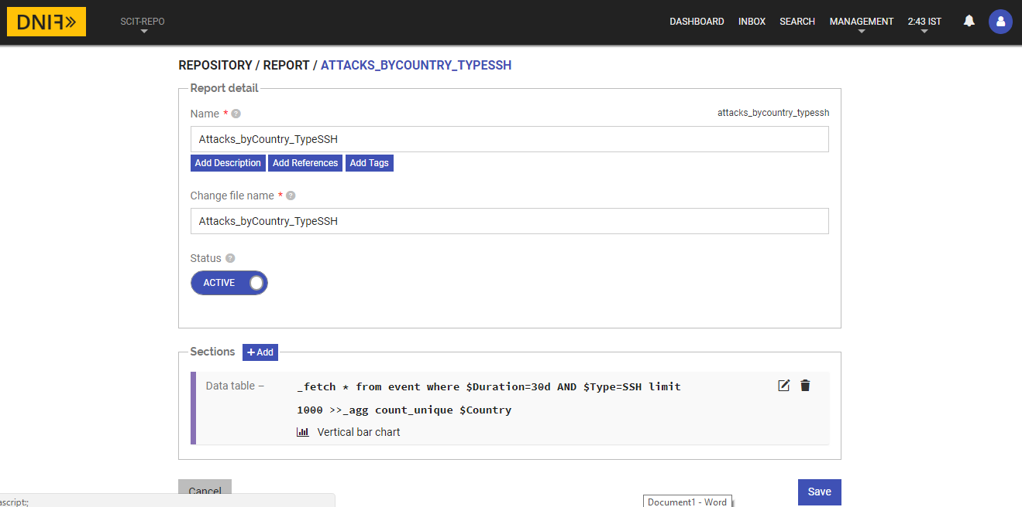

Email:

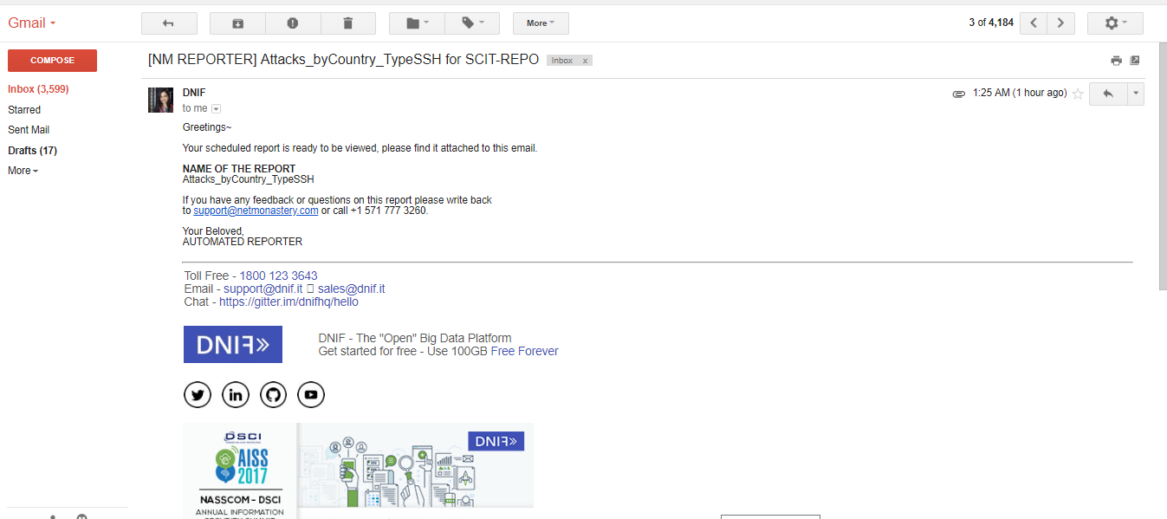

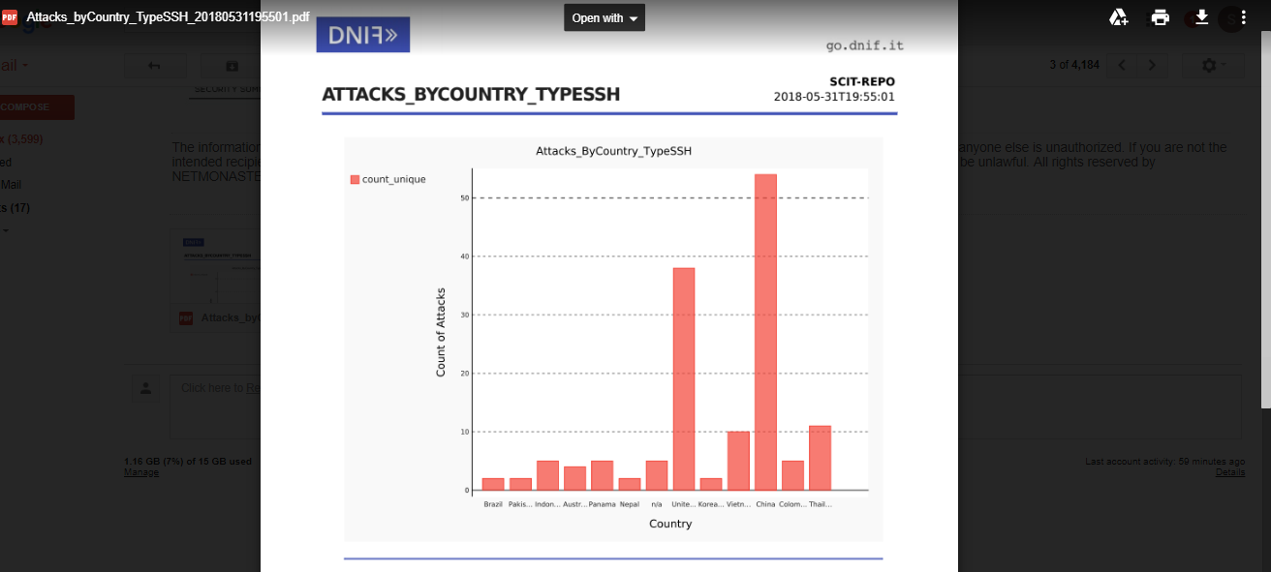

5. To trigger an alert based on attacks occurring in India and report the count of IP Addresses for originating attacks in the last 30 days.

Query: _trigger report bruteforce attacks_byipaddress_countryindia notify_email sayalisawant1518@gmail.com

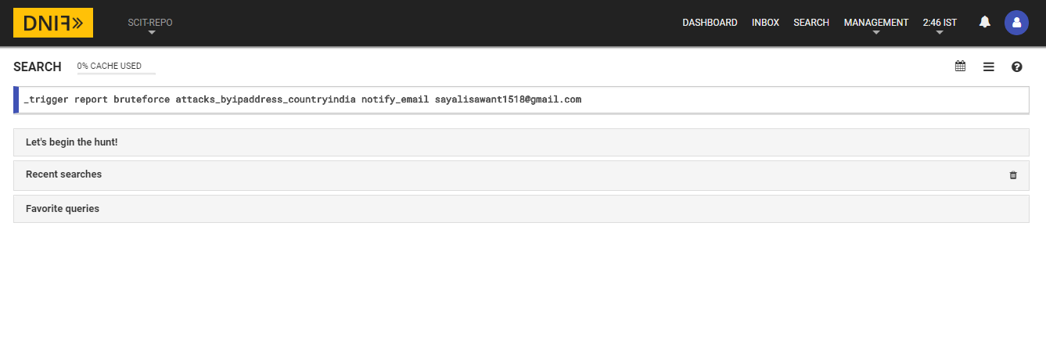

Report:

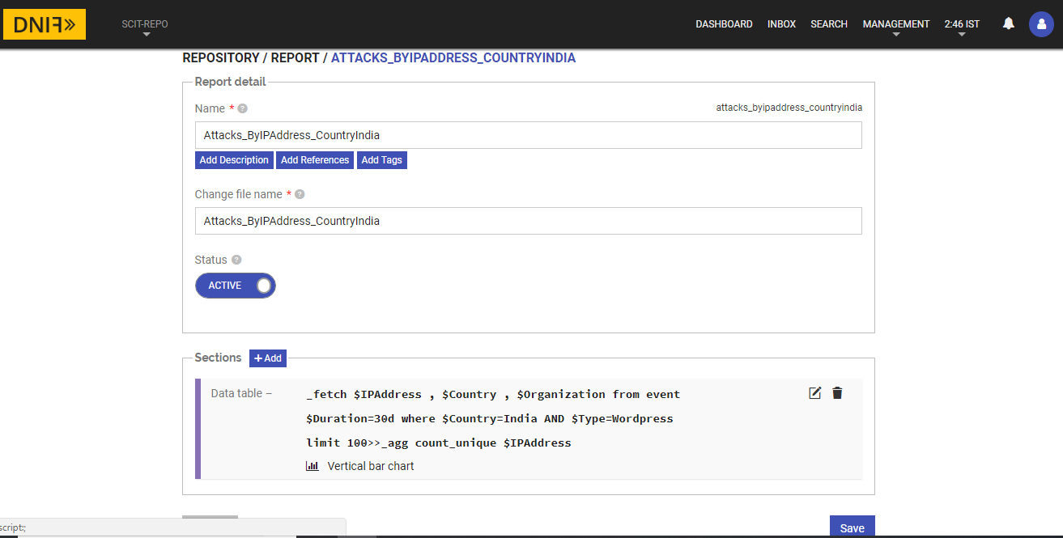

Email:

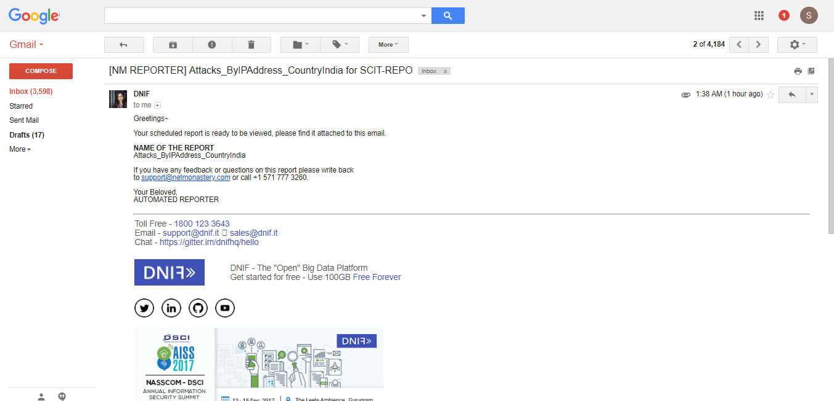

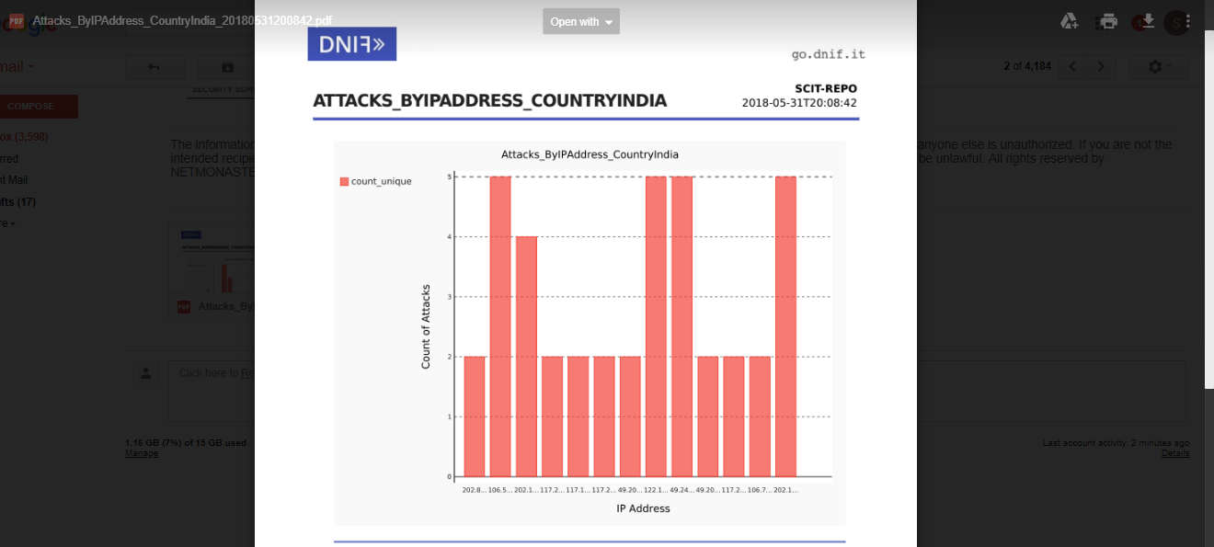

6. To trigger an alert based on Type of attack in the last 30 days.

Query : _trigger report bruteforce attacks_bytype notify_email sayalisawant1518@gmail.com

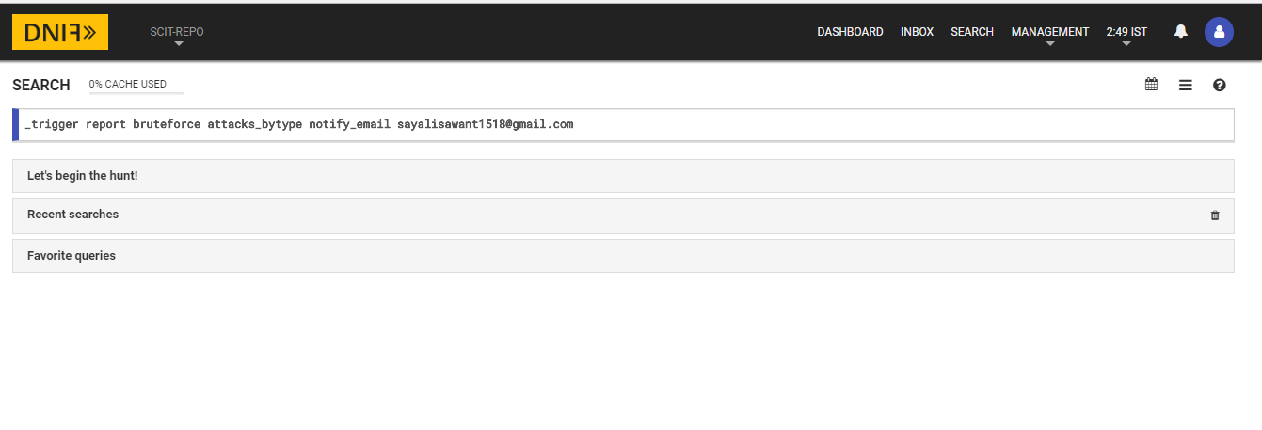

Report:

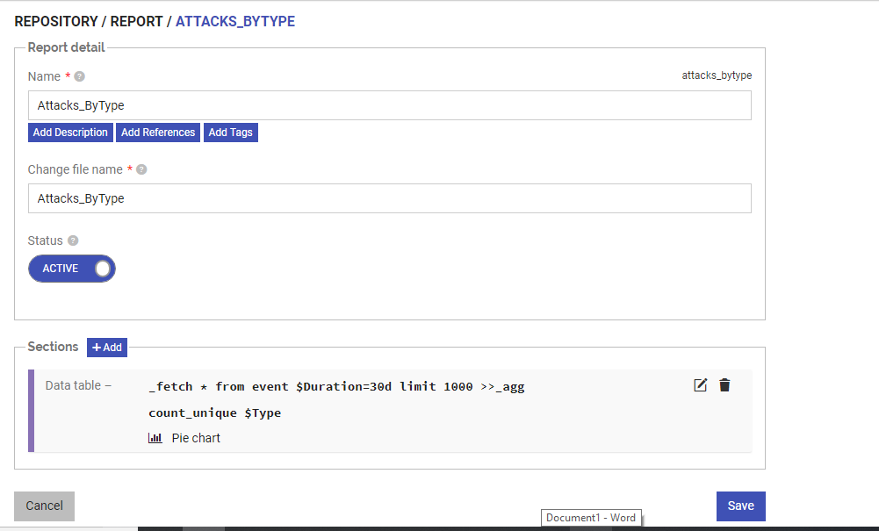

Email:

